Mike Abrahams : Assignment 1 Paragraph

\*Write a paragraph or so relating your insights to the Norris reading about electoral reform and women's representation. Picking a handful of country cases from your data, how does your analysis relate to her arguments about the relevance of electoral systems, statutory quotas, reserved seats or voluntary quotas?\*

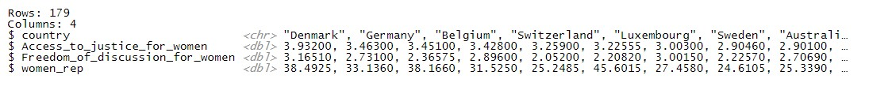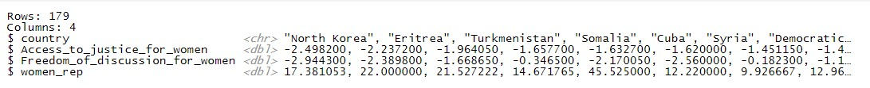

When looking at our top nations when ranked by Access to Justice for women Germany, Sweden and Australia are discussed in the Norris article. There are high levels of female representation on parliament and other government positions. In addition, we also see high levels for freedom of discussion. While our lower nations have negative values in the two positions our top nations are achieve closer to maximum values. What is also interesting is that the quotas and reserved seats like New Zealand do not make this list. The data I compiled perhaps takes more note of the overall tradition of representations going beyond what is legally binding. The question of freedom of discussion is not as legally enforceable as mandatory quotas. What is legally binding however is access to justice for women. The Justice systems on the top list, and in opposition those on the lowest end reflect the justice system of the nation overall.